All listing belong to Will Parker 406-407-6662 or will@fmgw.net
Additional pictures available.

Spring Cleaning:

Sidi Waterproof Leather Adventure Boots Size 10 (do not stink) $150

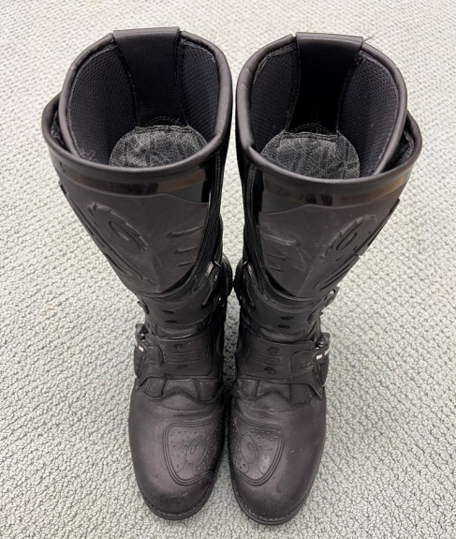

Mosko Moto Reckless 40 $250
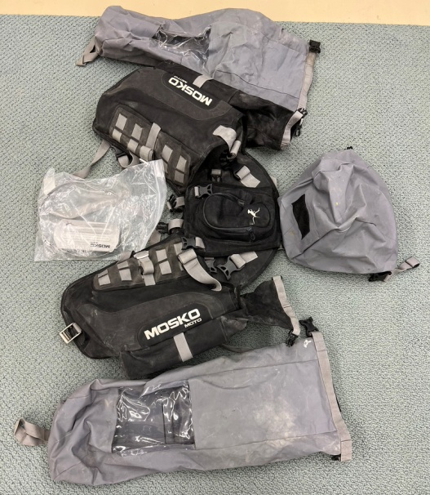

BMW GS/GSA Handlebars $200

Cardo Packtalk Bold w/Extra Helmet Kit $240 (NIB)
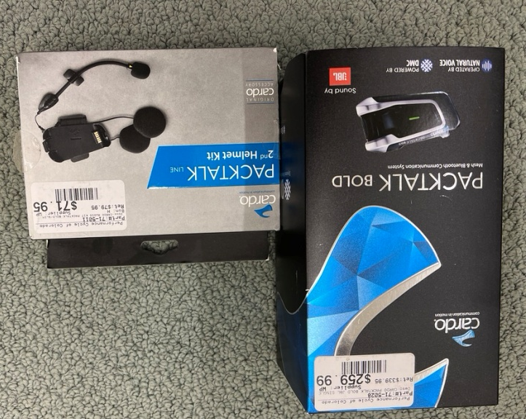

BMW Nav System $75

Dunlop Trailmax(120/70 x 19) $FREE (this tire struck an object. No visible damage. Fine for slow speed. Highspeed is your own risk).

BMW GSA Front Wheel for parts $FREE (this wheel struck an object. Visible damage. Parts or repair).
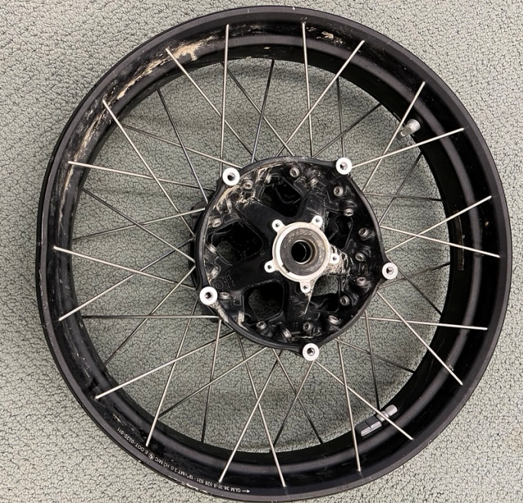

H-D Sundowner Seat $150
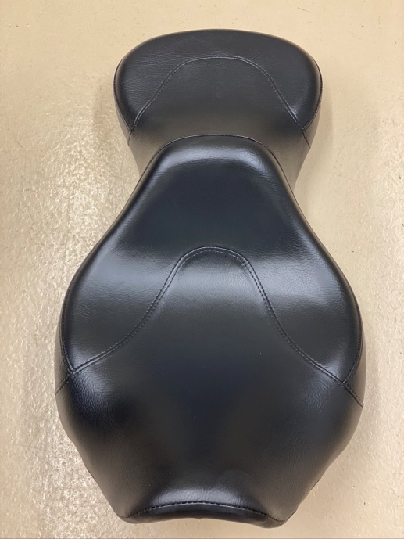

H-D Sissy Bar w/Rack in Black Wrinkle $100
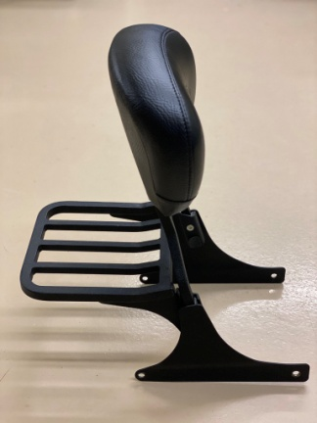
H-D Deuce Risers $50
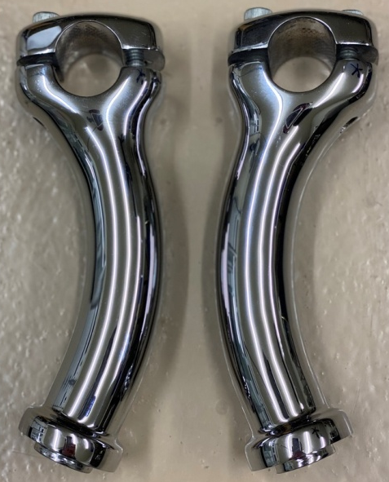

H-D Flow Through Jacket w/Removable Outer Shell Size M $100
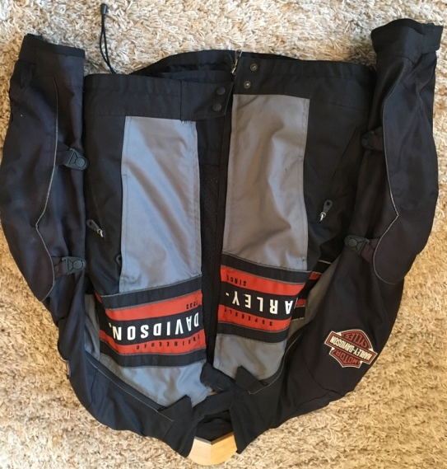

H-D FXRG Leather Jacket Size L $150
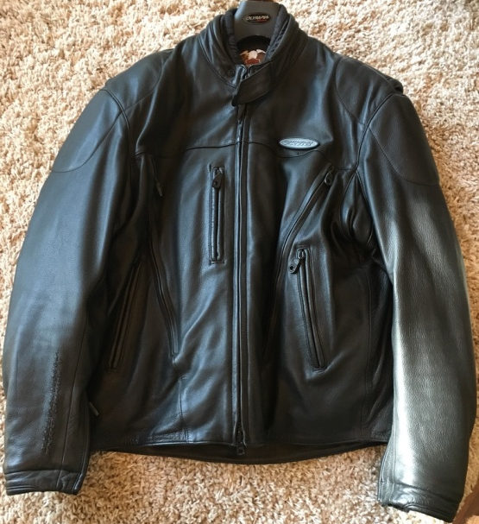
2014 KTM 1190 Adventure R 4667 Miles $11,500
- Black Dog Skid, Pegs, and Rear Rack
- Tourtech Hard Bags w/Fuel Slot
